User Interface

1. Page Tab



1. Homepage

Login Button

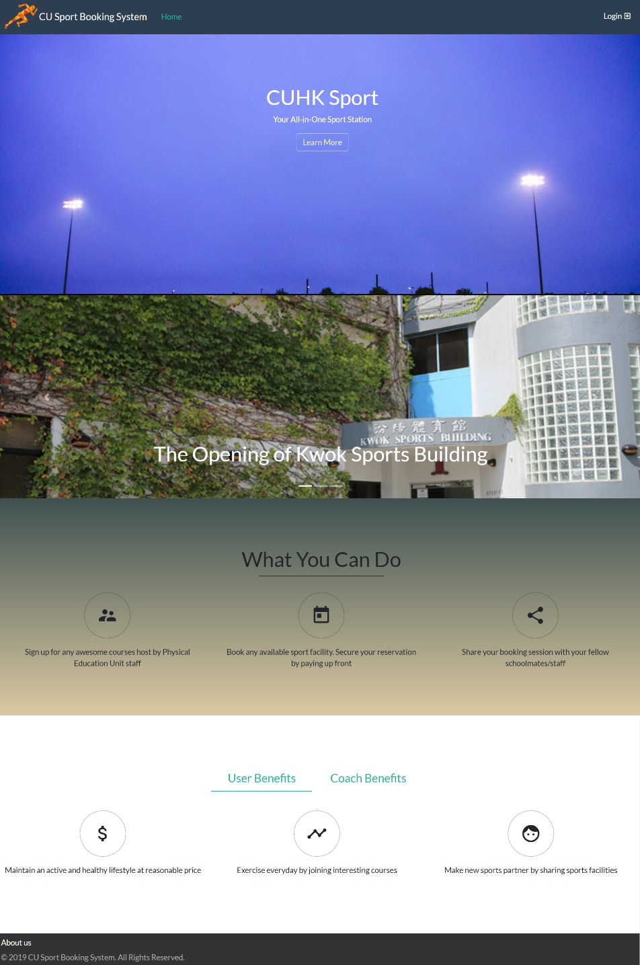

Announcement Slideshow

1. About Us

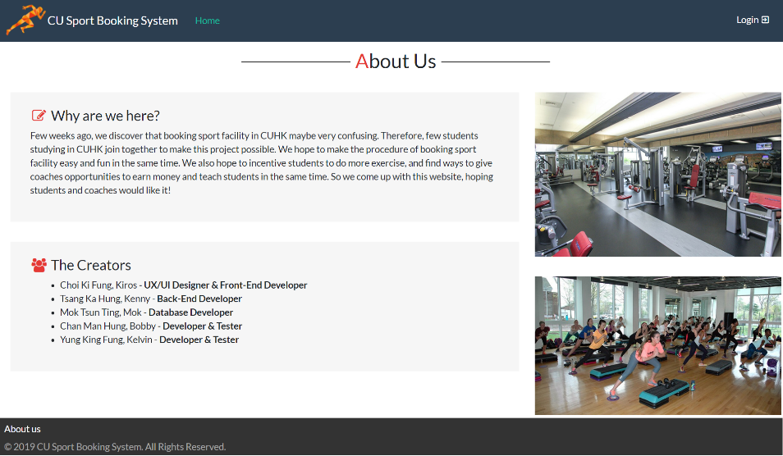

1. Announcement Detail

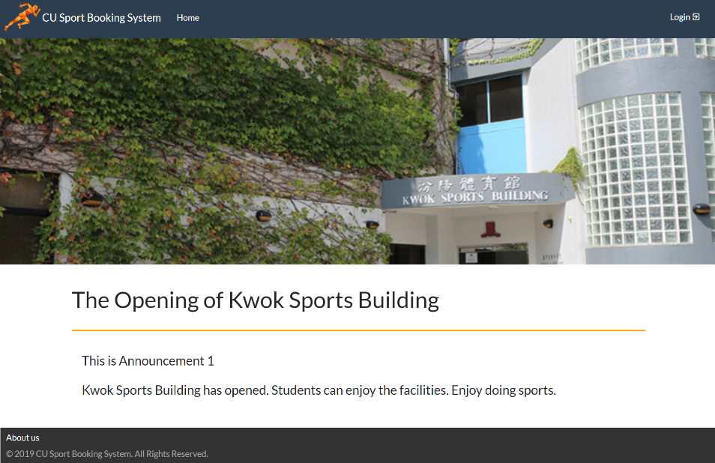

1. Login Page

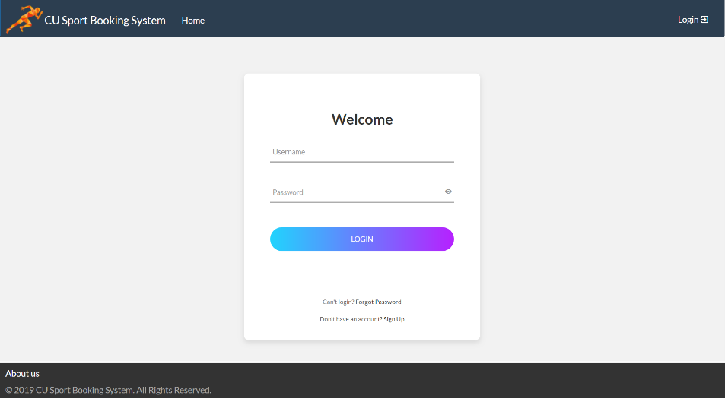

Username and Password field

Show/Hide Password character

Sign Up for account

Forget Password

Login Button

1. Login Success

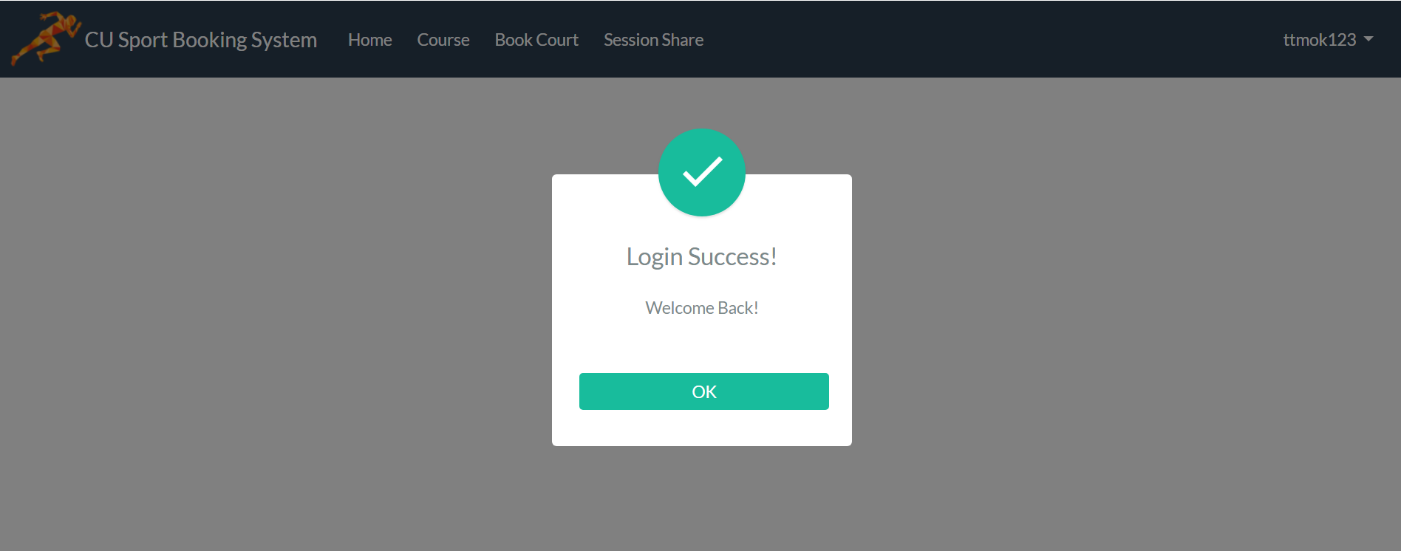

Proceed to Homepage

1. Sign Up Form

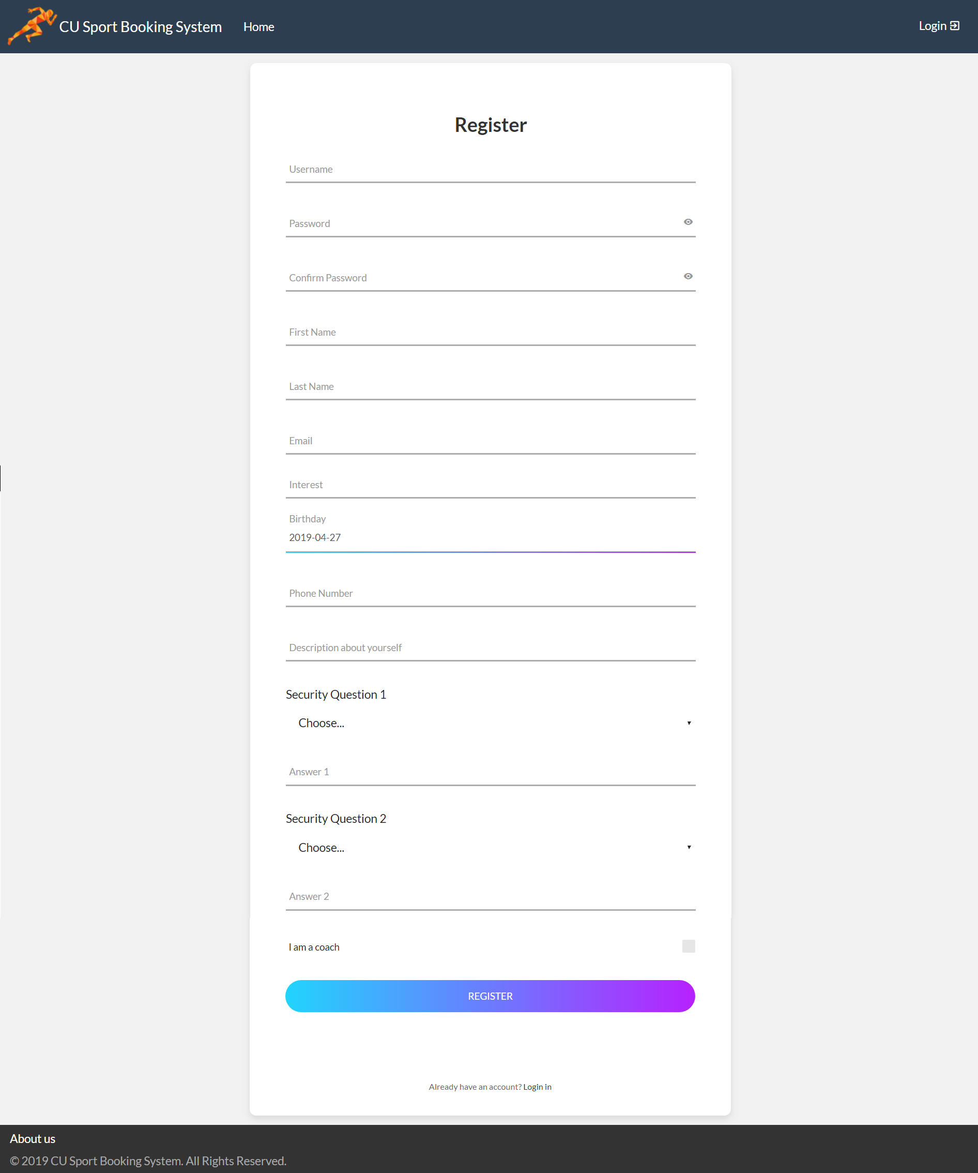

Contact Number

Self-Introduction

User’s interest

Email address

Last name field

First name field

Confirm Password

Password field

Username field

Security questions for password reset

Login existing account

Register Button

Checkbox for coach

Birthday

1. Register Success

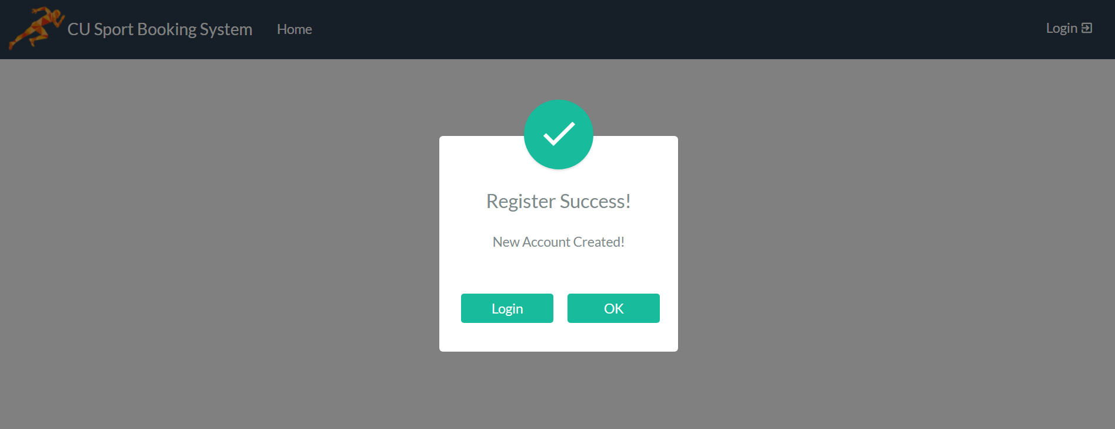

Proceed to Login

Return to Homepage

1. Forget Password

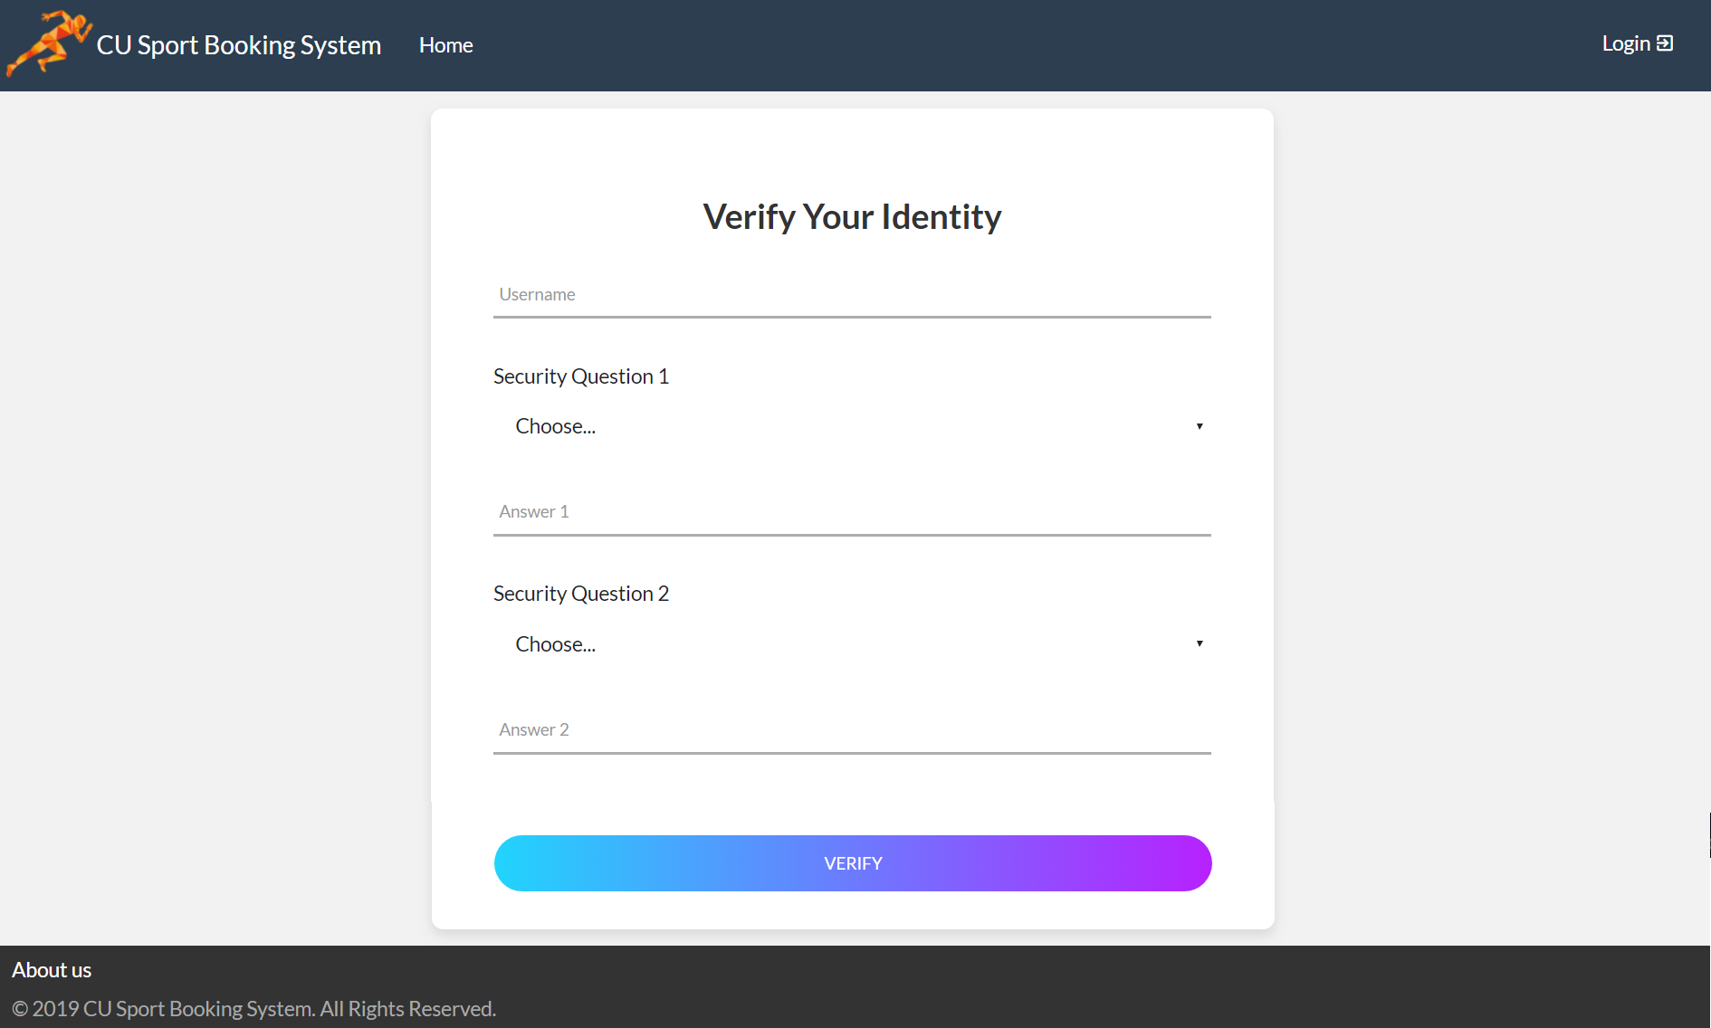

Verify Identity

Answer Security Question 2

Answer Security Question 1

Input Username

1. Password Reset Success

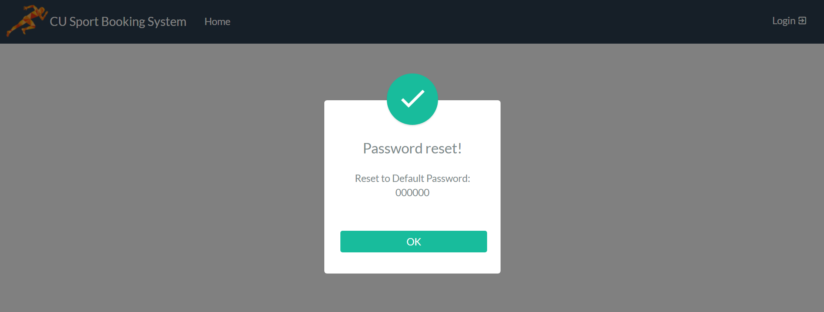

Return to Homepage

1. Change Password

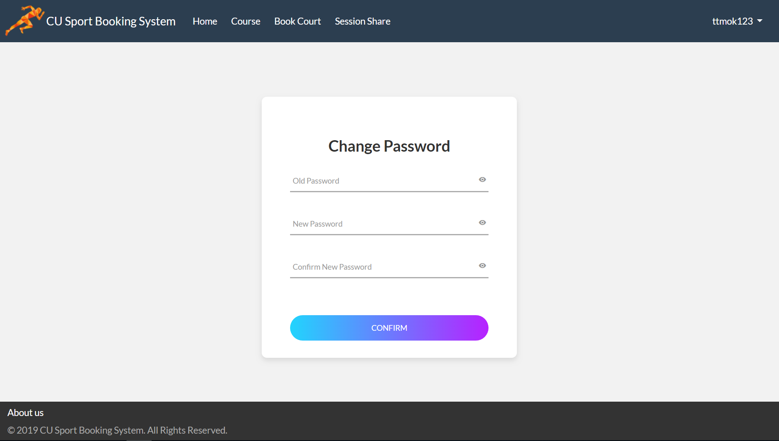

Input Old Password

Confirm Changes

Confirm New Password

Input New Password

1. Administrator Navigation Bar and Settings

Show Username

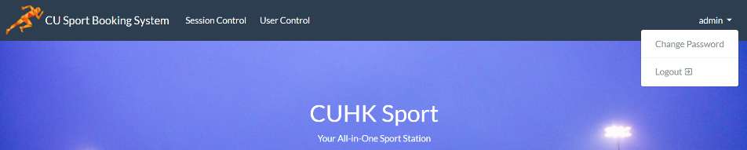

Access User Control

Access Session Control

1. Add Sport Sessions

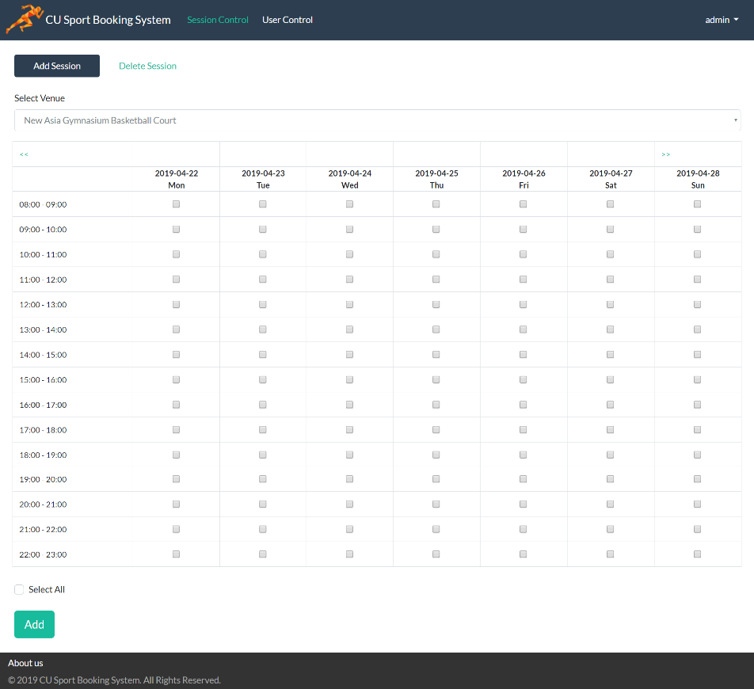

Venue Selection

Date

Checkboxes for selection

Add Selected Session

Time Slots

Add Session Panel

1. Delete Sport Sessions

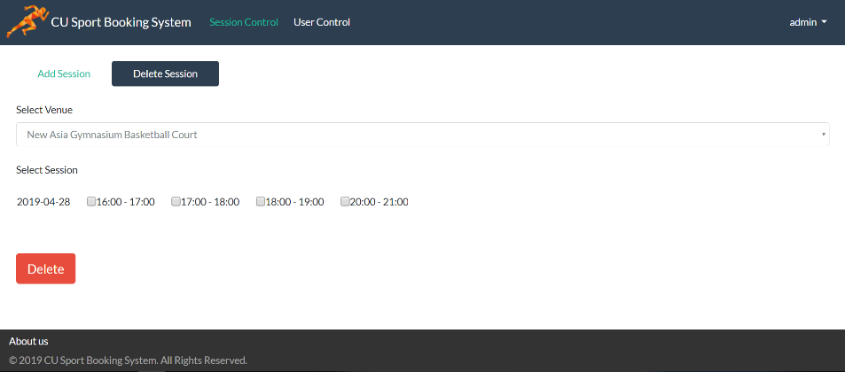

Delete Selected Sessions

Delete Session Panel

Venue Selection

Existing Sessions and Checkboxes

1. Reset Password for Users

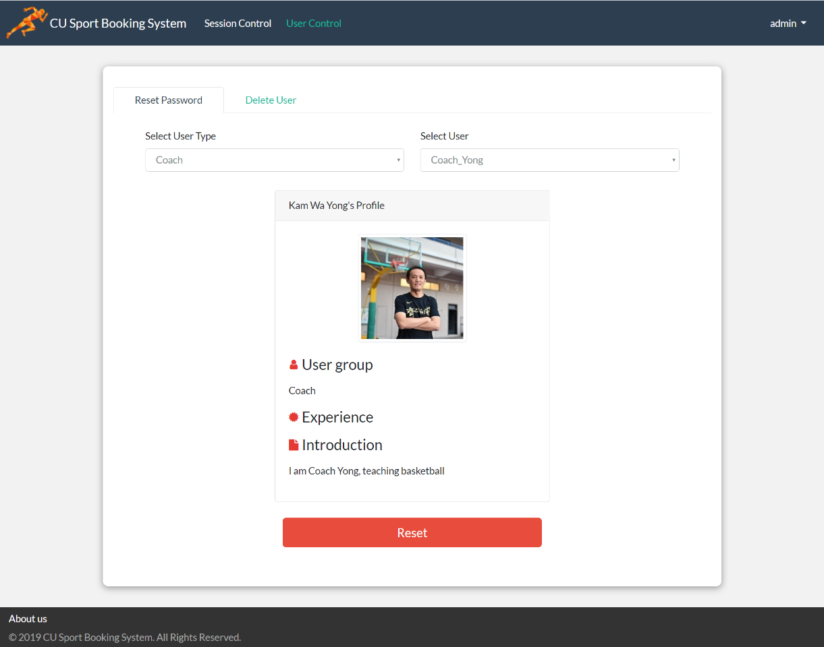

Reset Button

User’s Profile

Select User

Filter by User Type

Reset Password Panel

1. Confirmation to Reset User Password

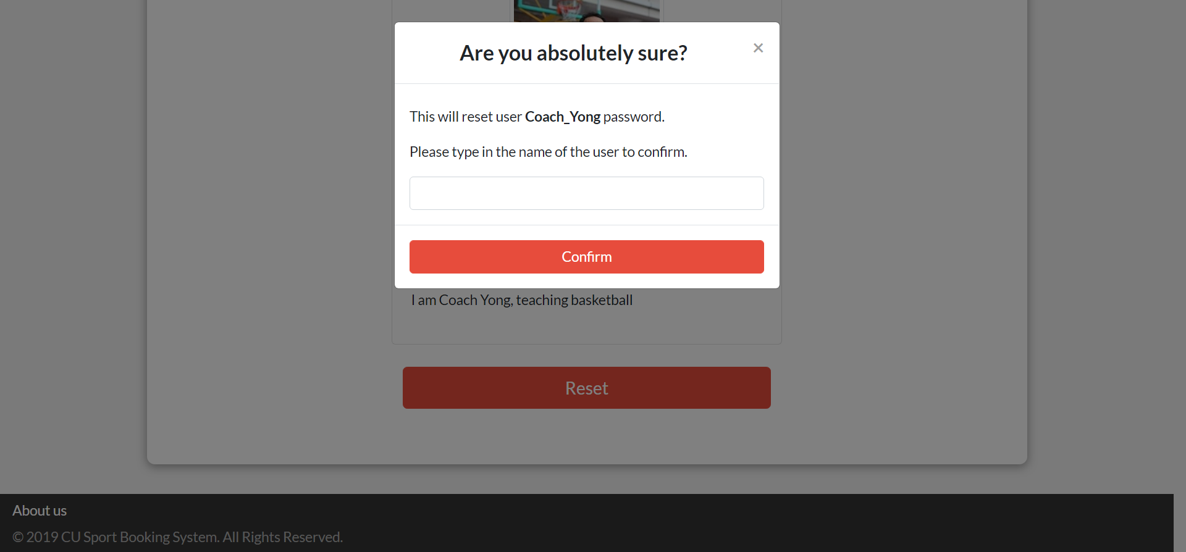

Confirm Reset

Confirm Username

1. Delete User

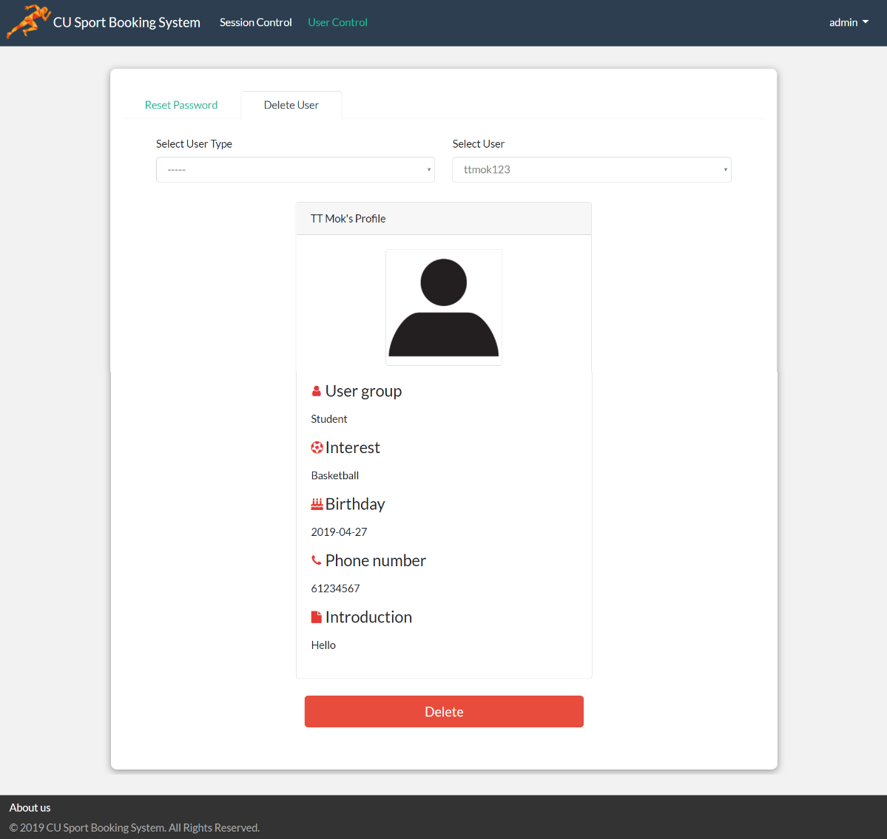

User’s Profile

Delete Button

Select User

Filter by User Type

Delete User Panel

1. Confirmation to Delete User

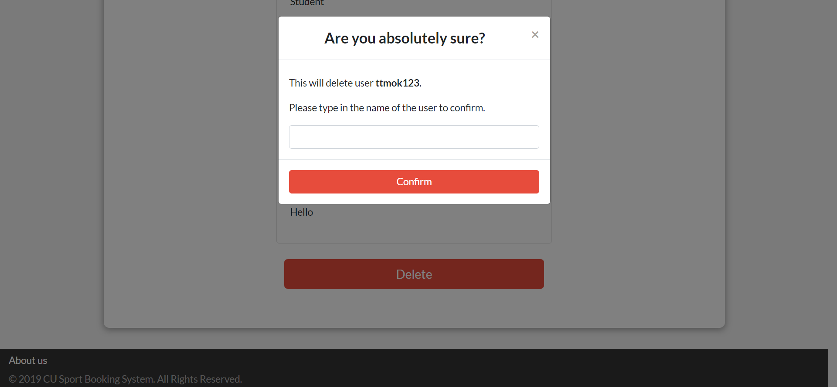

Confirm Reset

Confirm Username

1. Coach Navigation Bar and Settings

Show Username

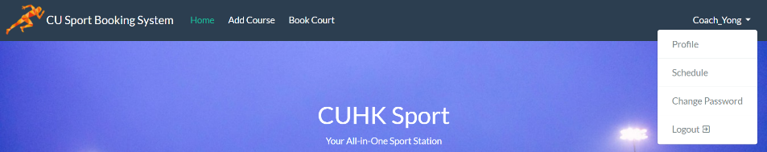

Book Facilities

Add Course

Input Course Name

1. Add Courses

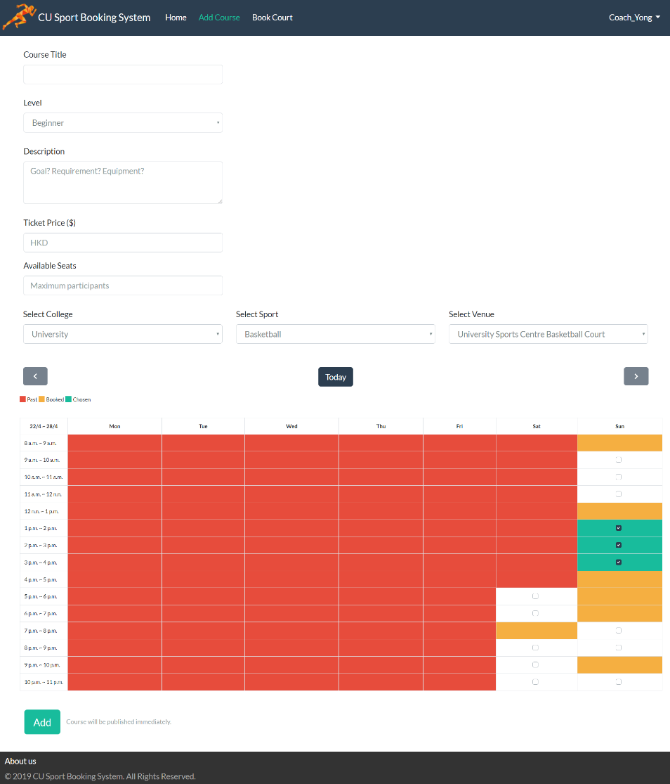

Create Course

Choose Available Session Slots

Select Course Level

Enter Course Description

Input Course Fee

Enter Course Capacity

Select Venue

1. Course Creation Confirmation

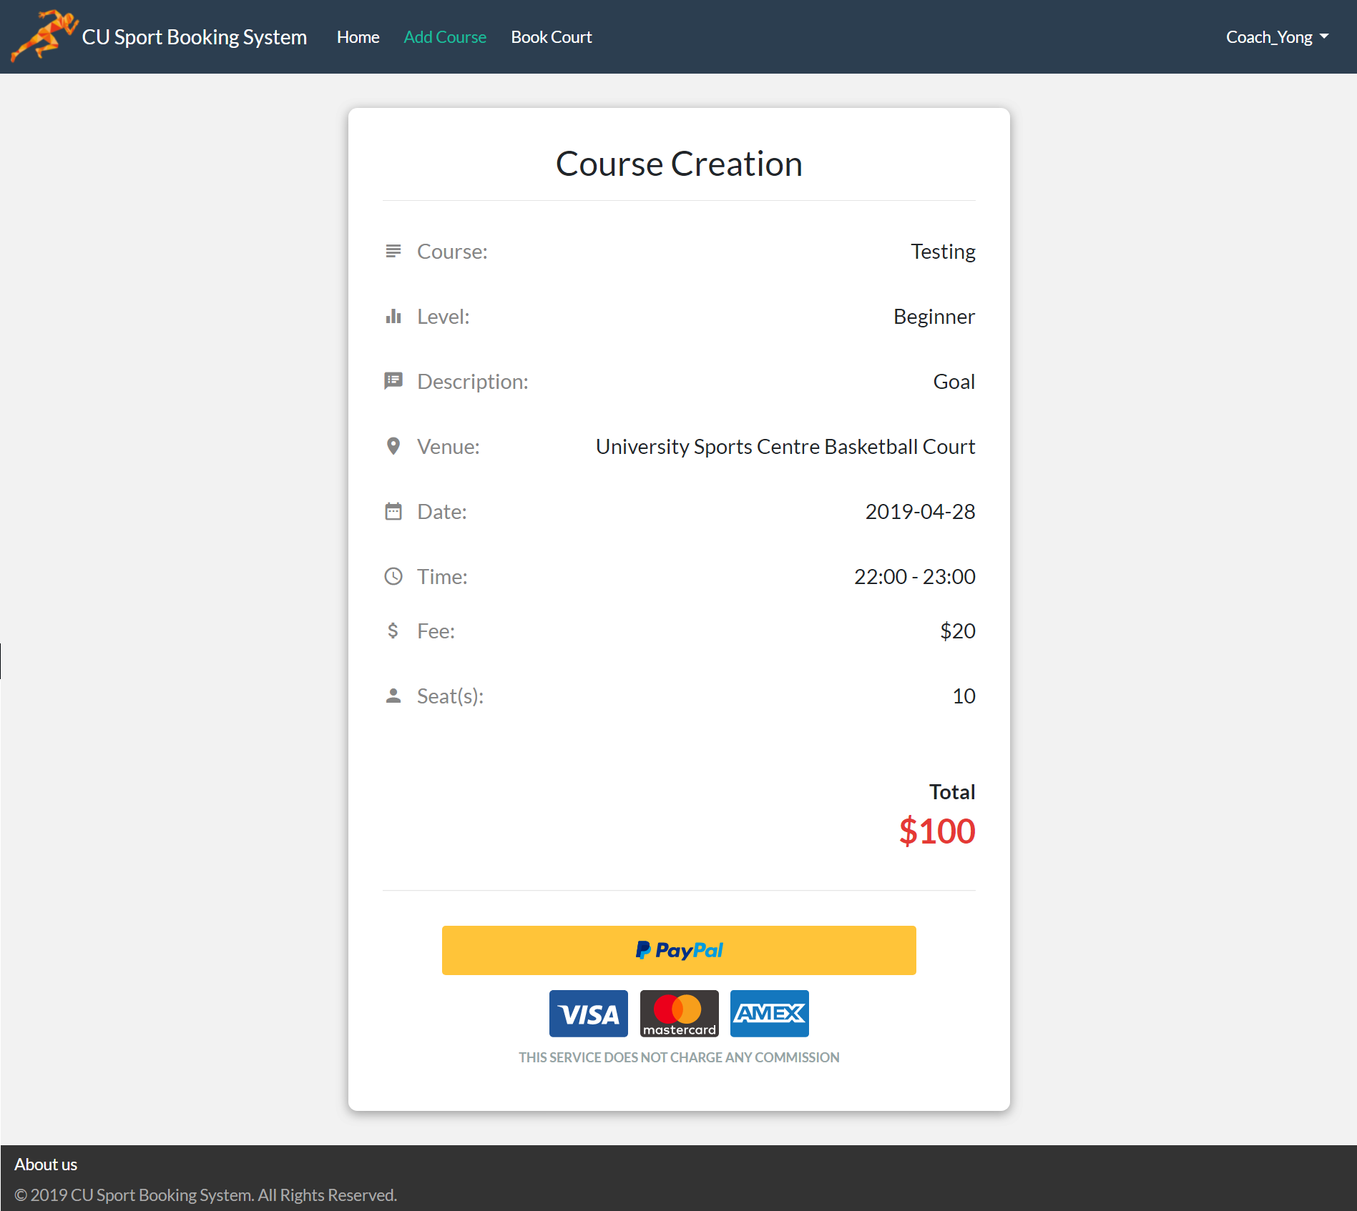

Proceed to Payment

Course Information

Facility Rental Fee

1. Course Creation Success

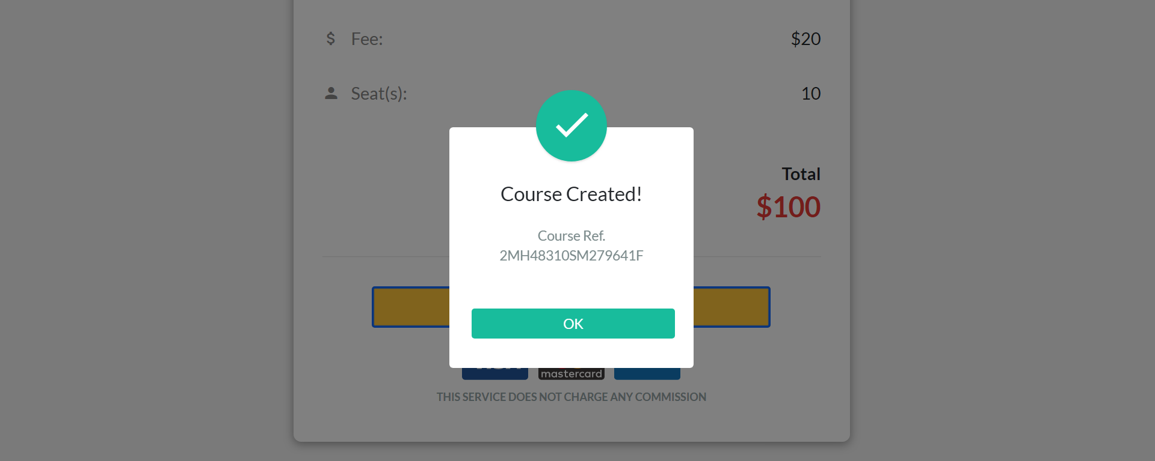

Return to Homepage

1. View Coach Schedule

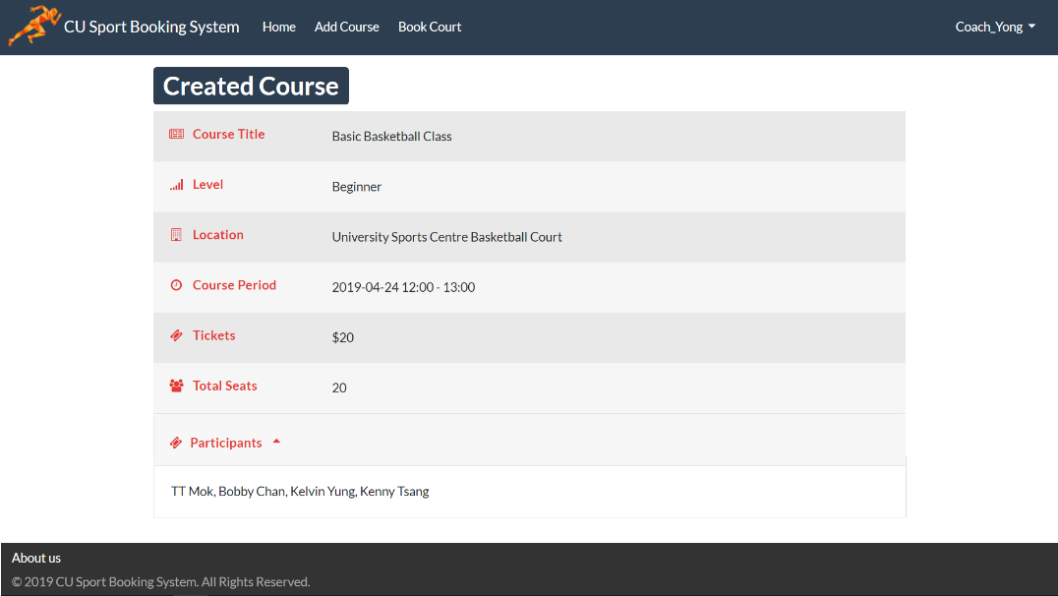

Course Information

Participants List

1. View Coach Profile

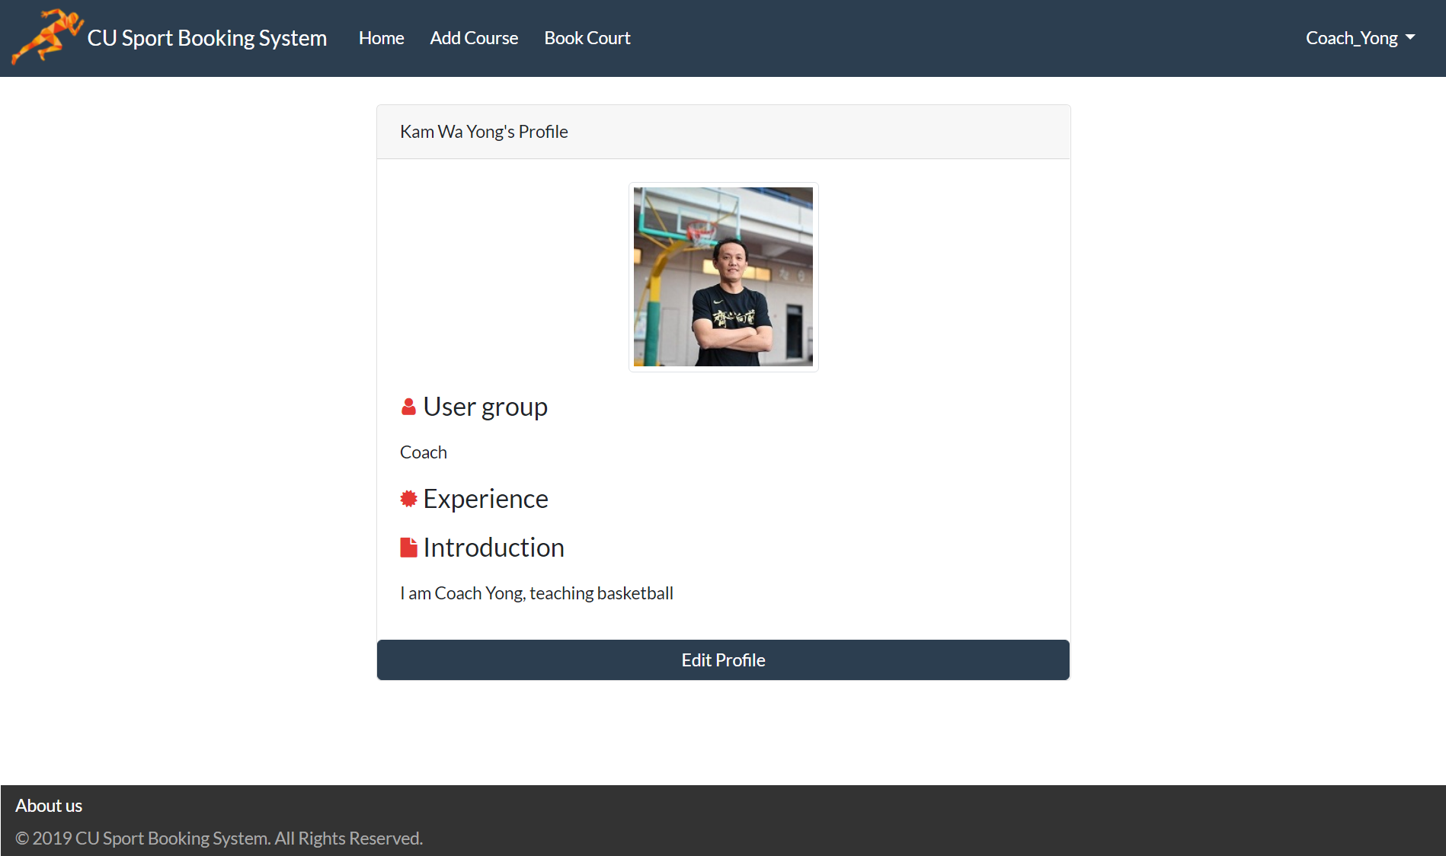

Edit Profile Button

1. Edit Coach Profile

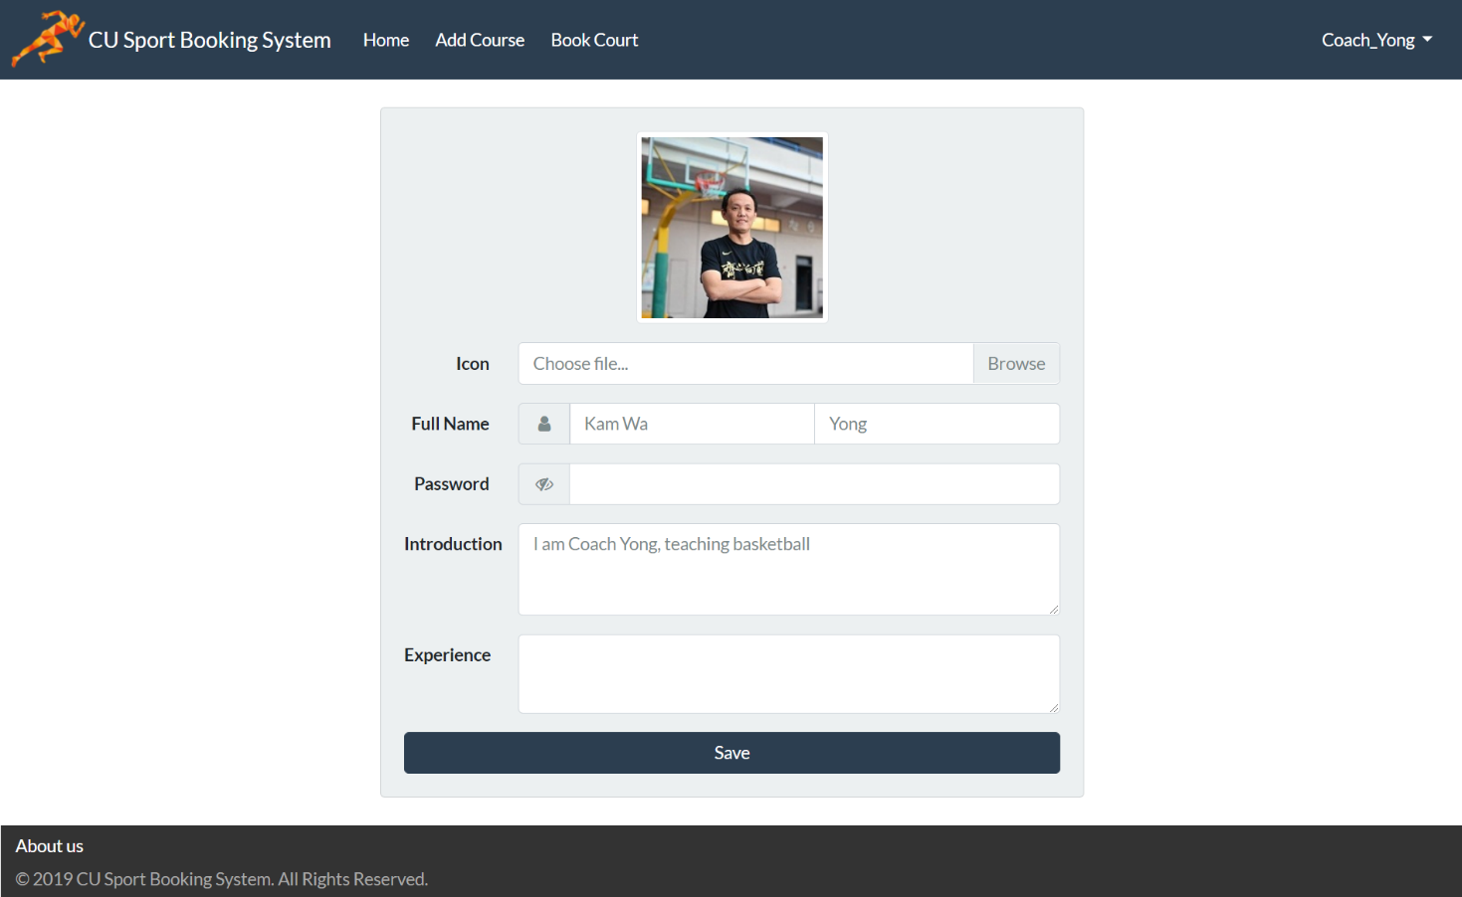

Input Password

Update

Self-Introduction

Update Experience

Upload and Change Profile Picture

Save Changes

1. Upload Profile Picture

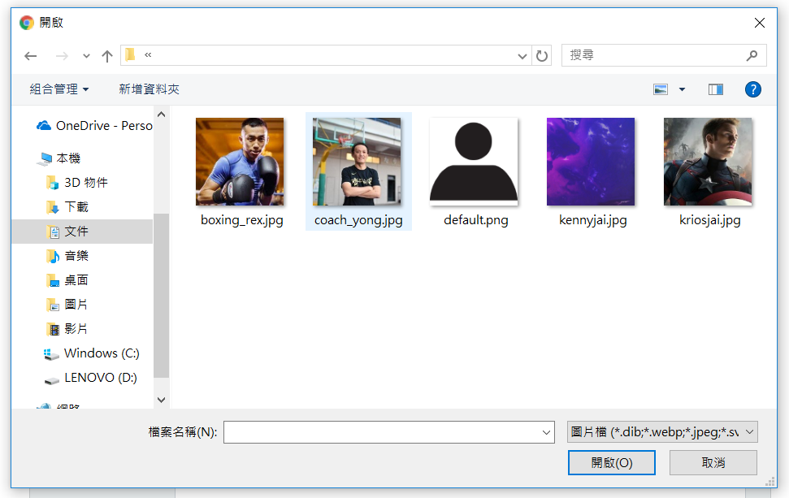

Select Images from Folder

Cancel

Confirm

1. Coach Navigation Bar and Settings

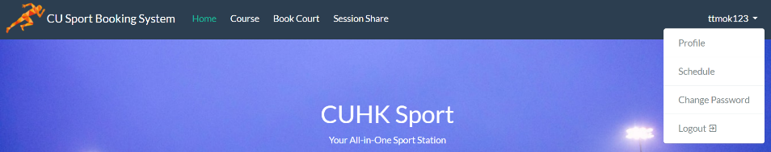

Share Facilities

Show Username

Book Facilities

View Courses

1. Browse Courses Catalog

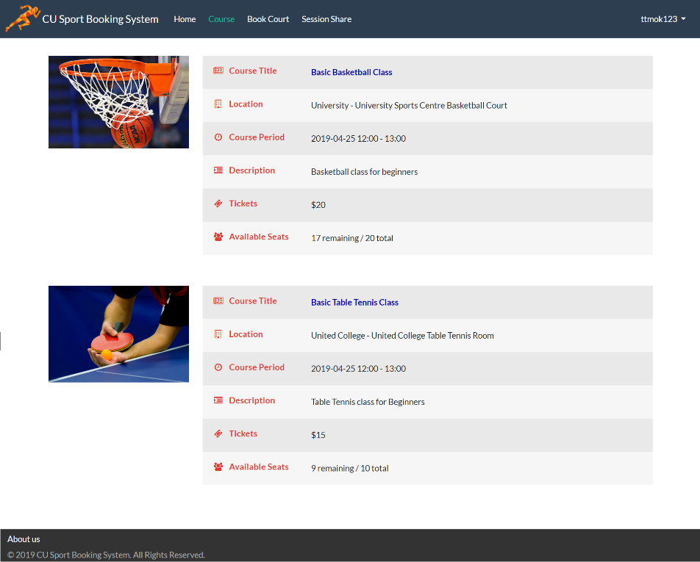

Basic Information

View Course Details

1. View Course Details

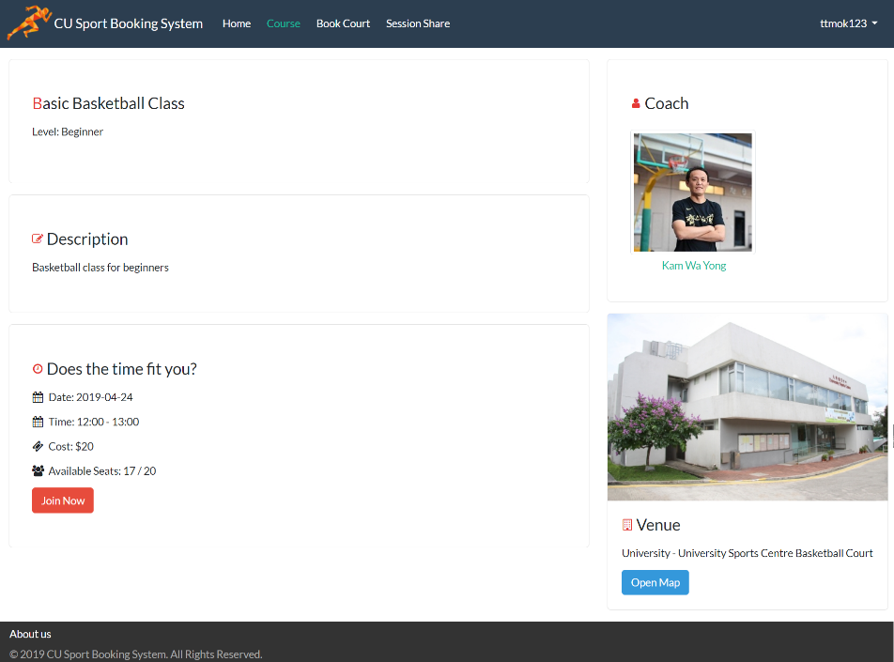

View Location on Map

Join Course

View Coach Profile

1. View Location on Map

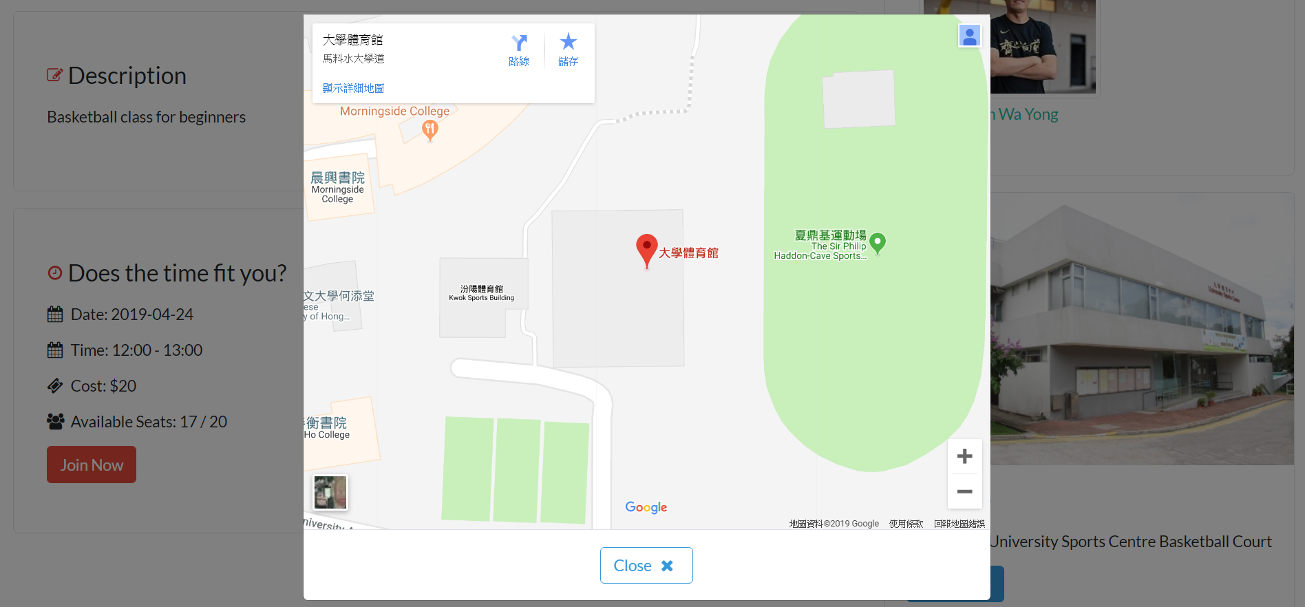

Close Map

Zoom In / Zoom Out

Street View

Location Pin

Location Information

1. View Coach Profile

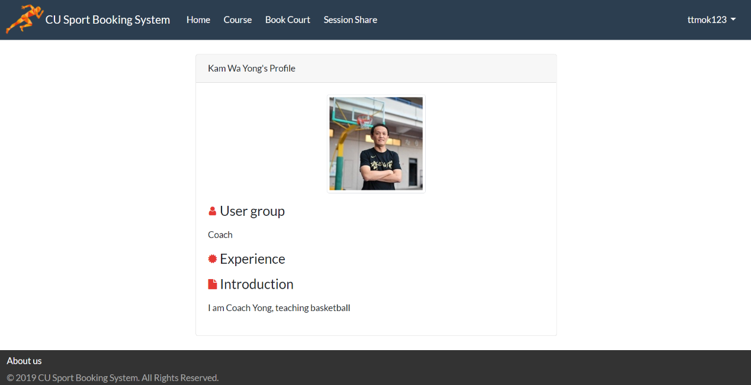

Coach Information

1. Join Course

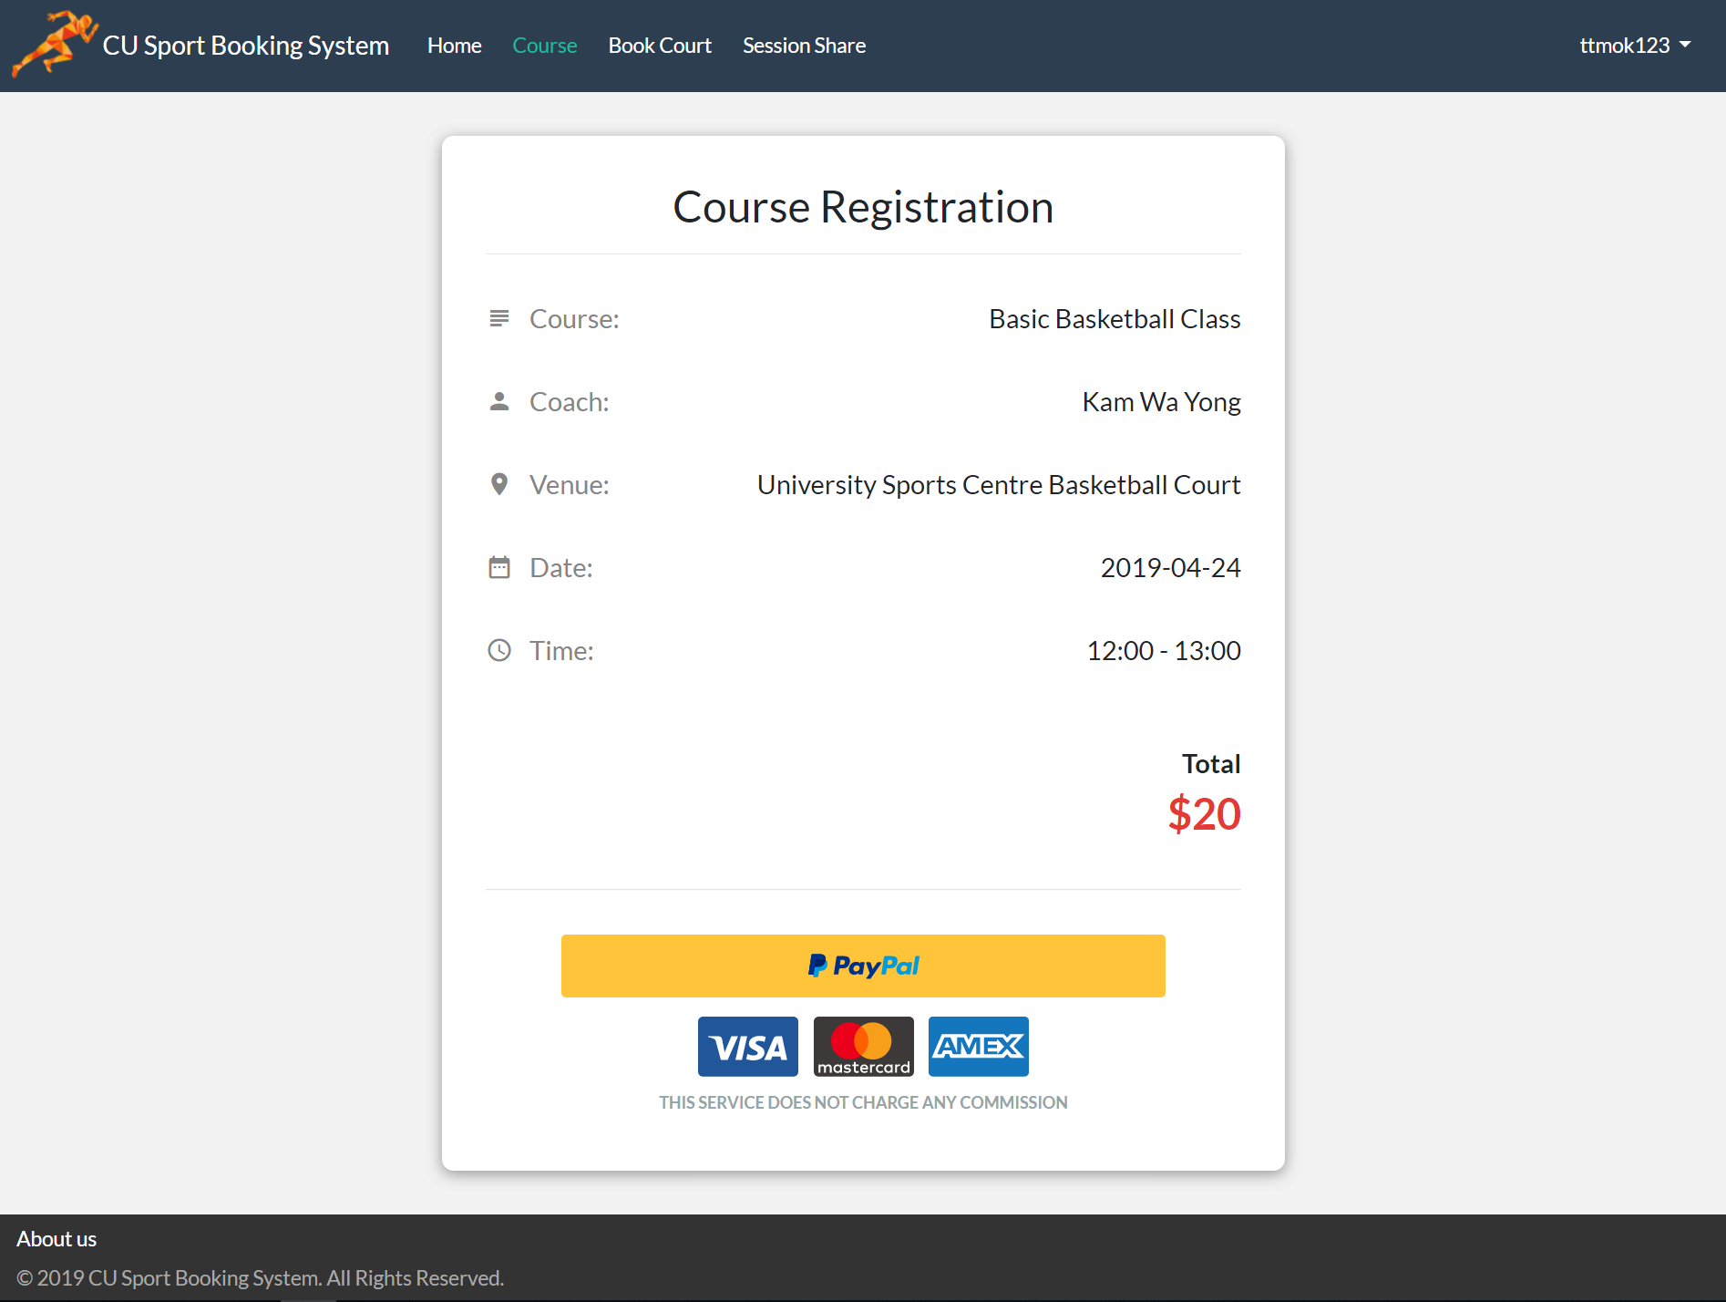

Proceed to Payment

Course Fee

Course Information

1. Course Registration Success

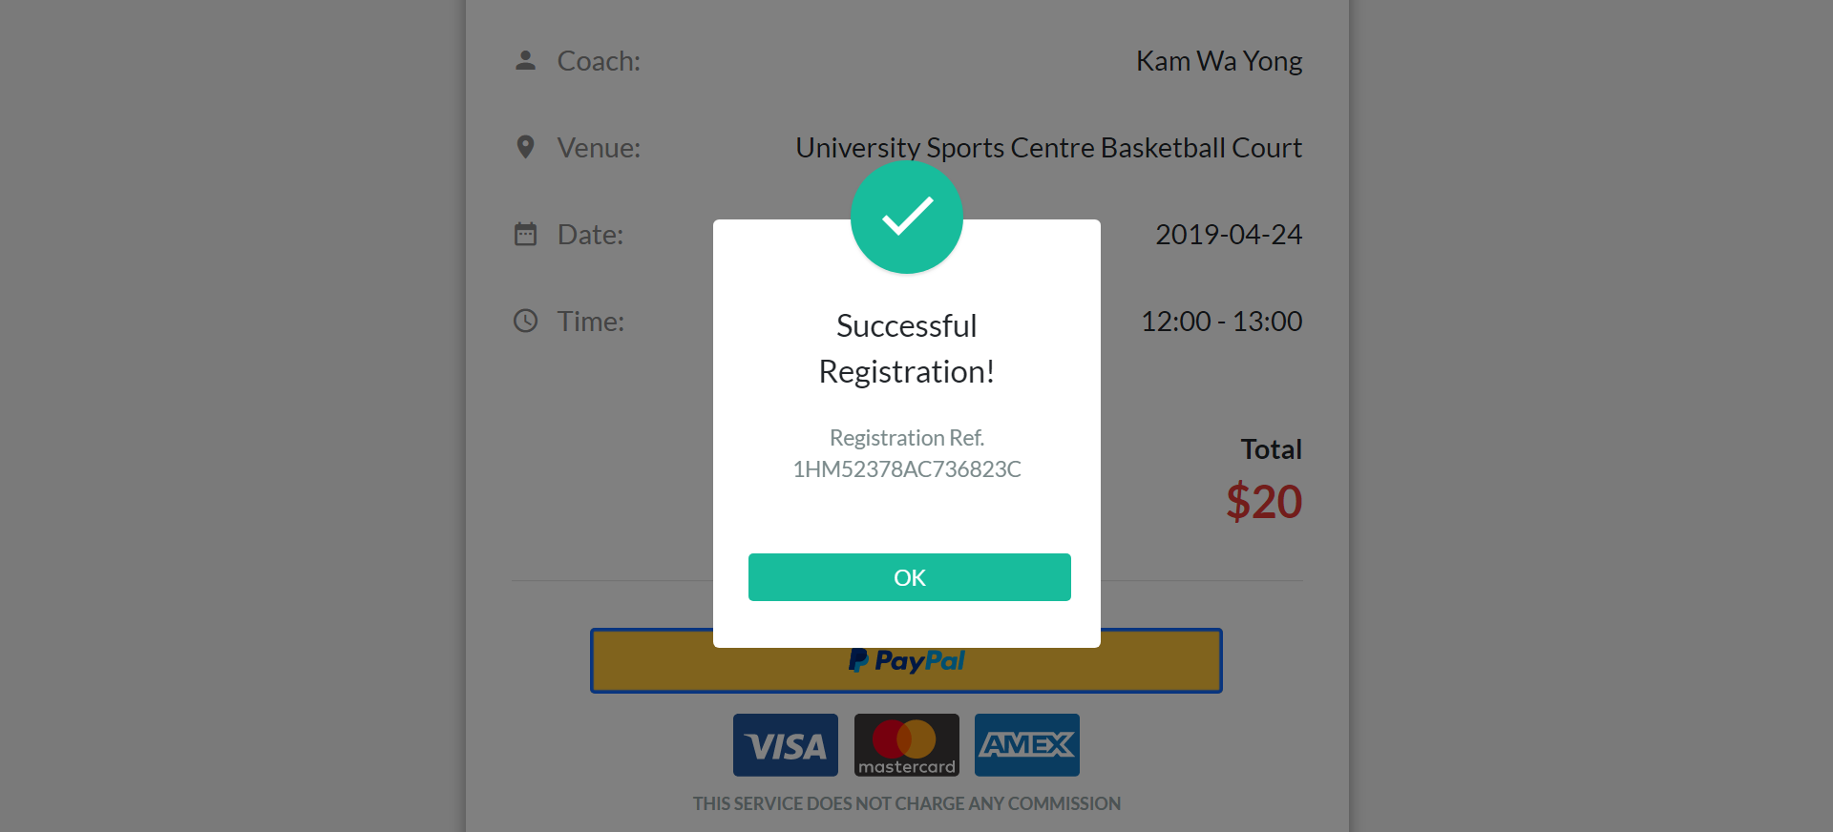

Return to Homepage

1. Browse Sport Facilities

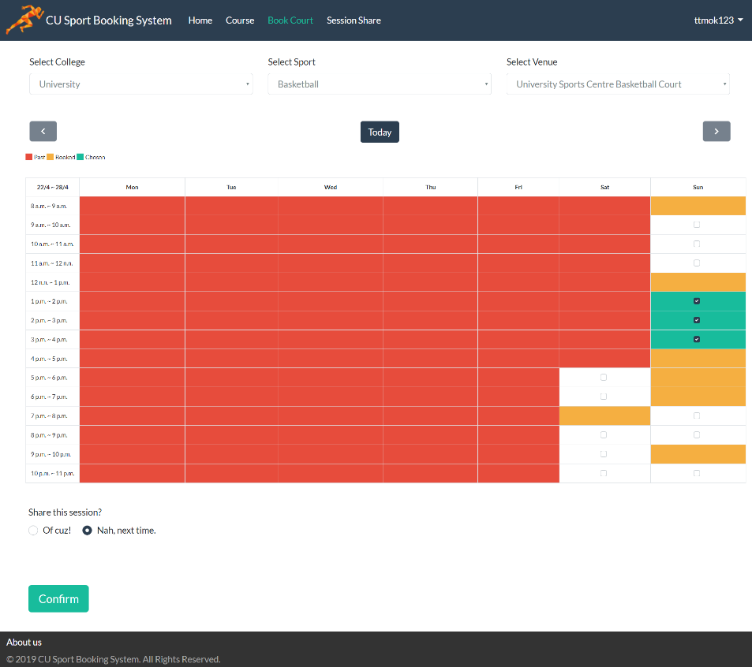

Venue Selection

Available Slots

Selected Slots

Occupied Slots

Expired Slots

Enable Peers Sharing

Confirm Booking

1. Booking Confirmation

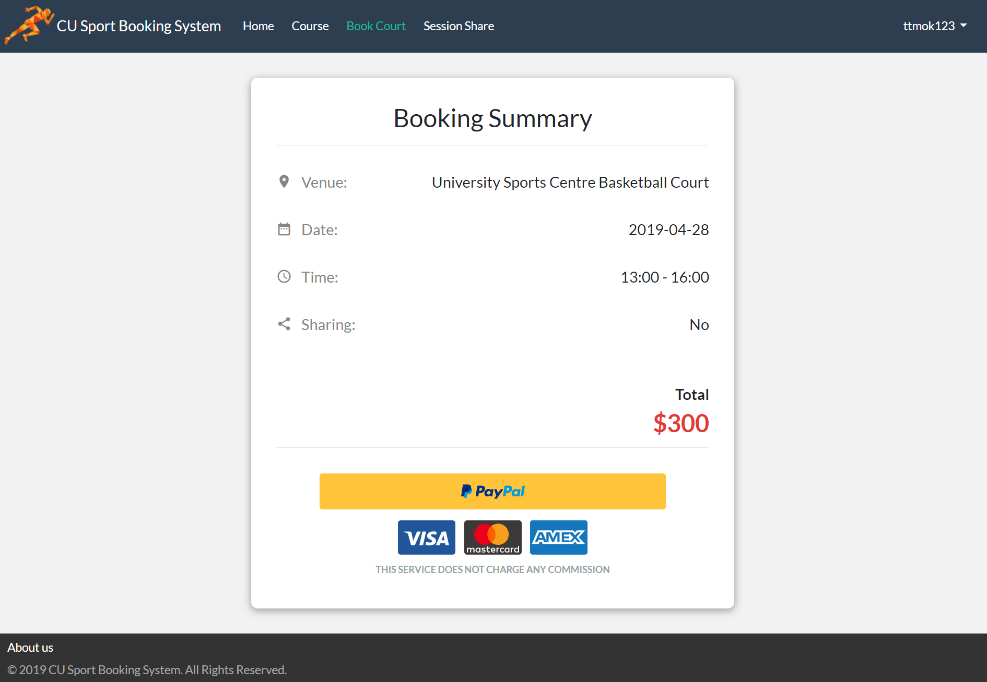

Proceed to Payment

Booking Fee

Booking Information

1. Browse Shared Sessions List

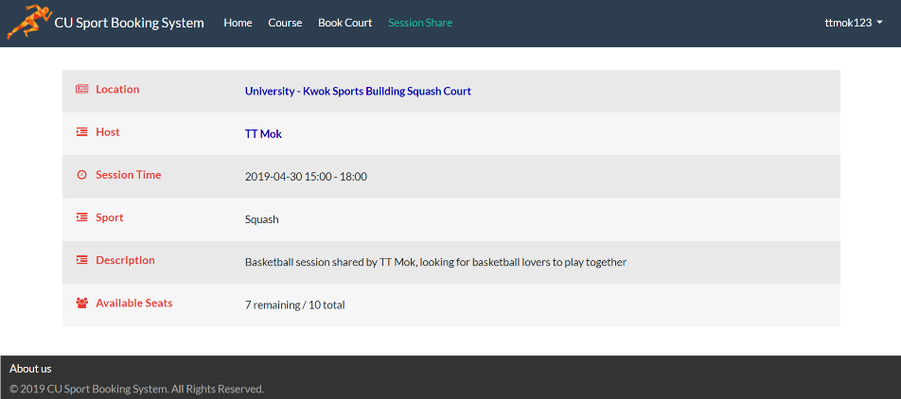

Basic Information

View Host Profile

View Session Details

1. View Shared Session Details

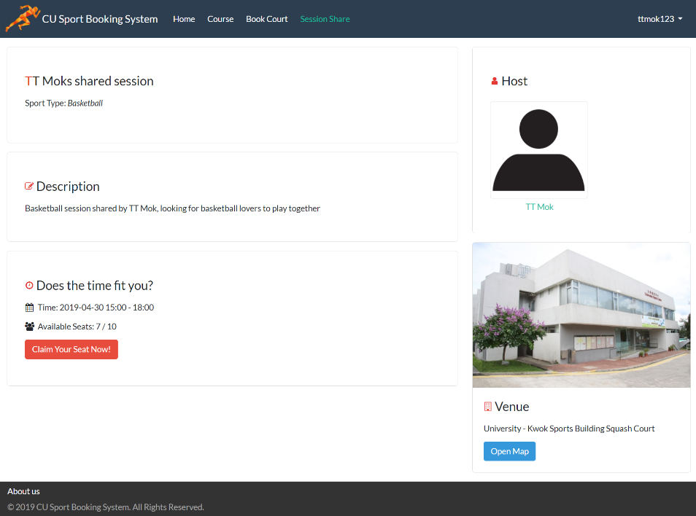

View Location on Map

Join Session

View Host Profile

1. View Host Profile

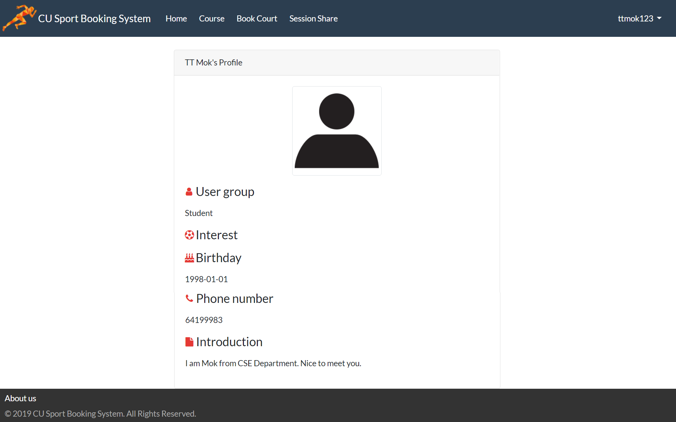

Host Information

1. View Student Schedule

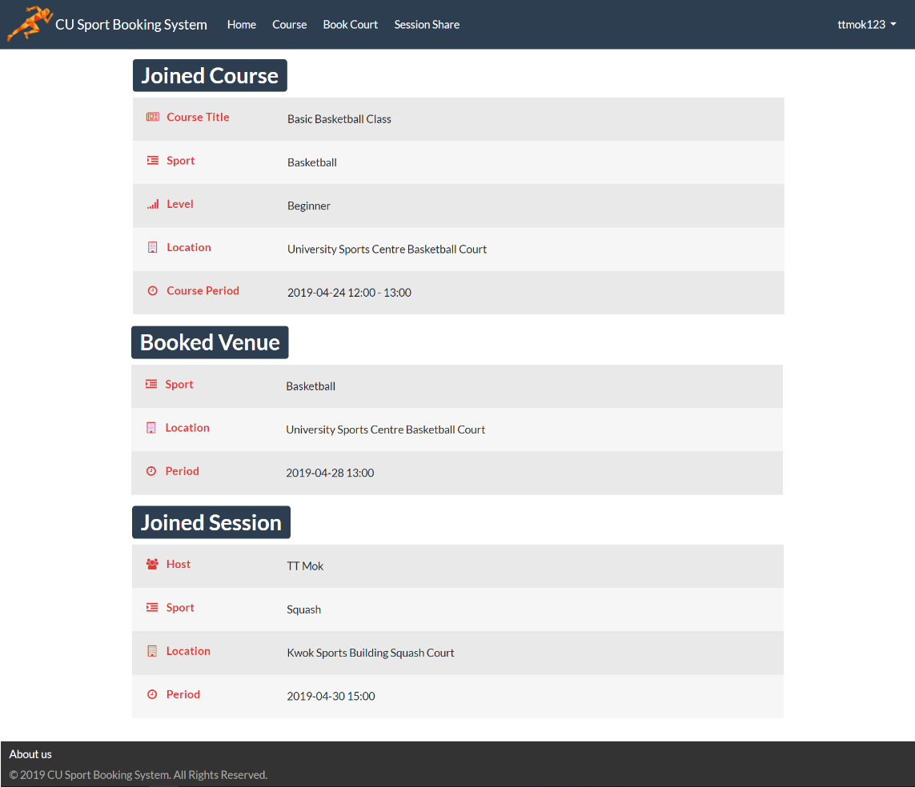

Shared Session Information

Booked Facilities Information

Joined Course Information

1. Edit Student Profile

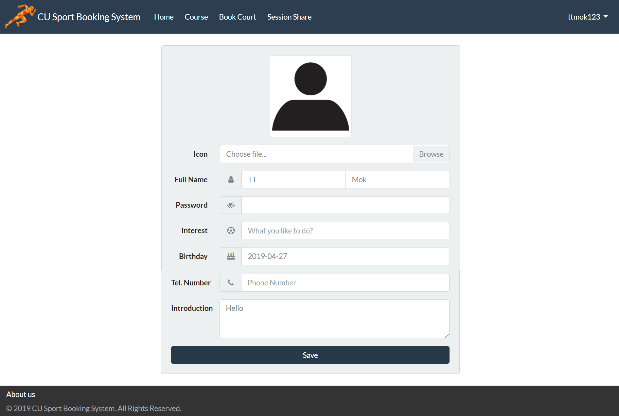

Input Password

Upload and Change Profile Picture

Update Interest

Update Phone Number

Update

Self-Introduction

Save Changes

1. Access Paypal Gateway

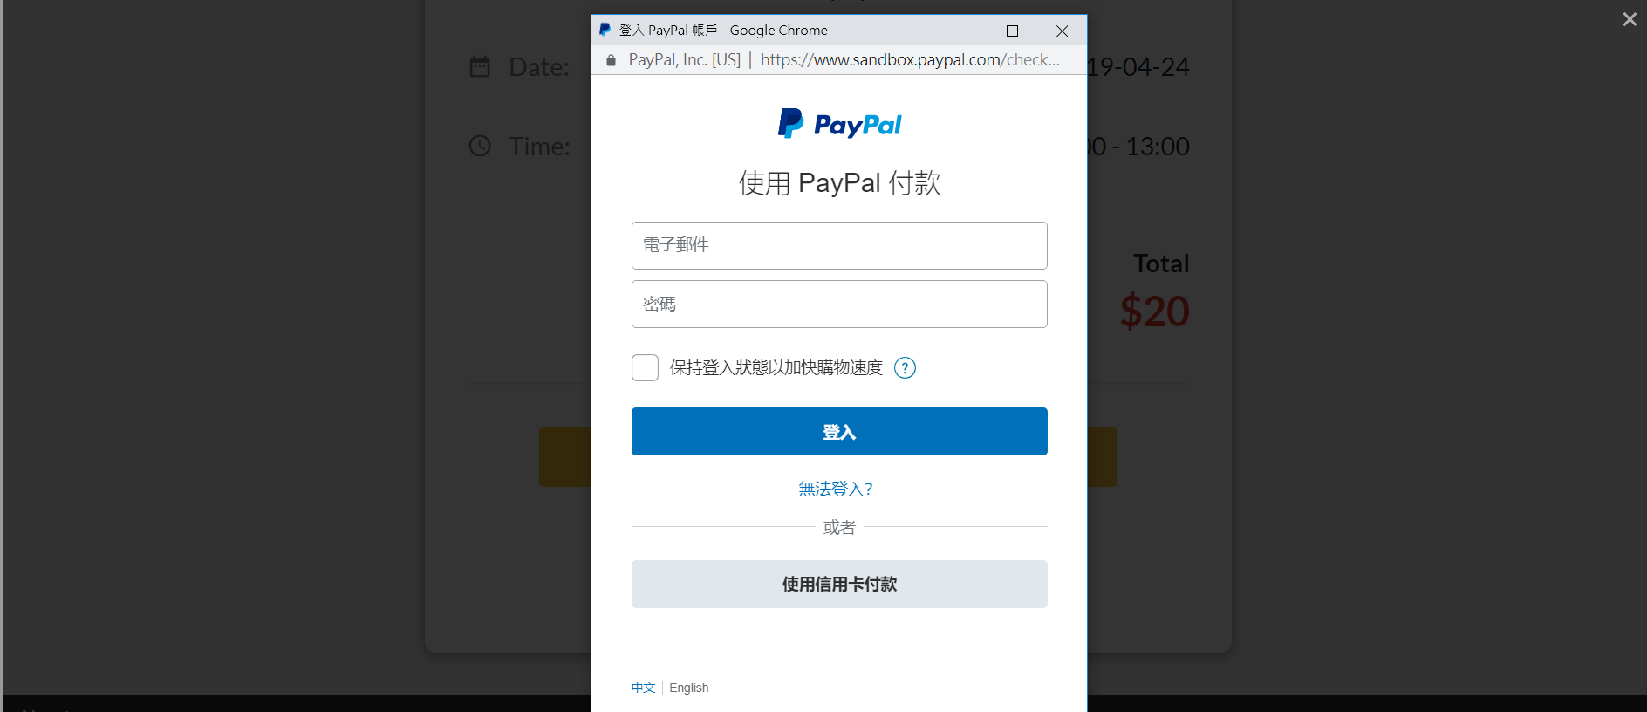

Input Password

Make Payment without Login

Login

Keep Logged In

Input Email Address

1. Choose Payment Method

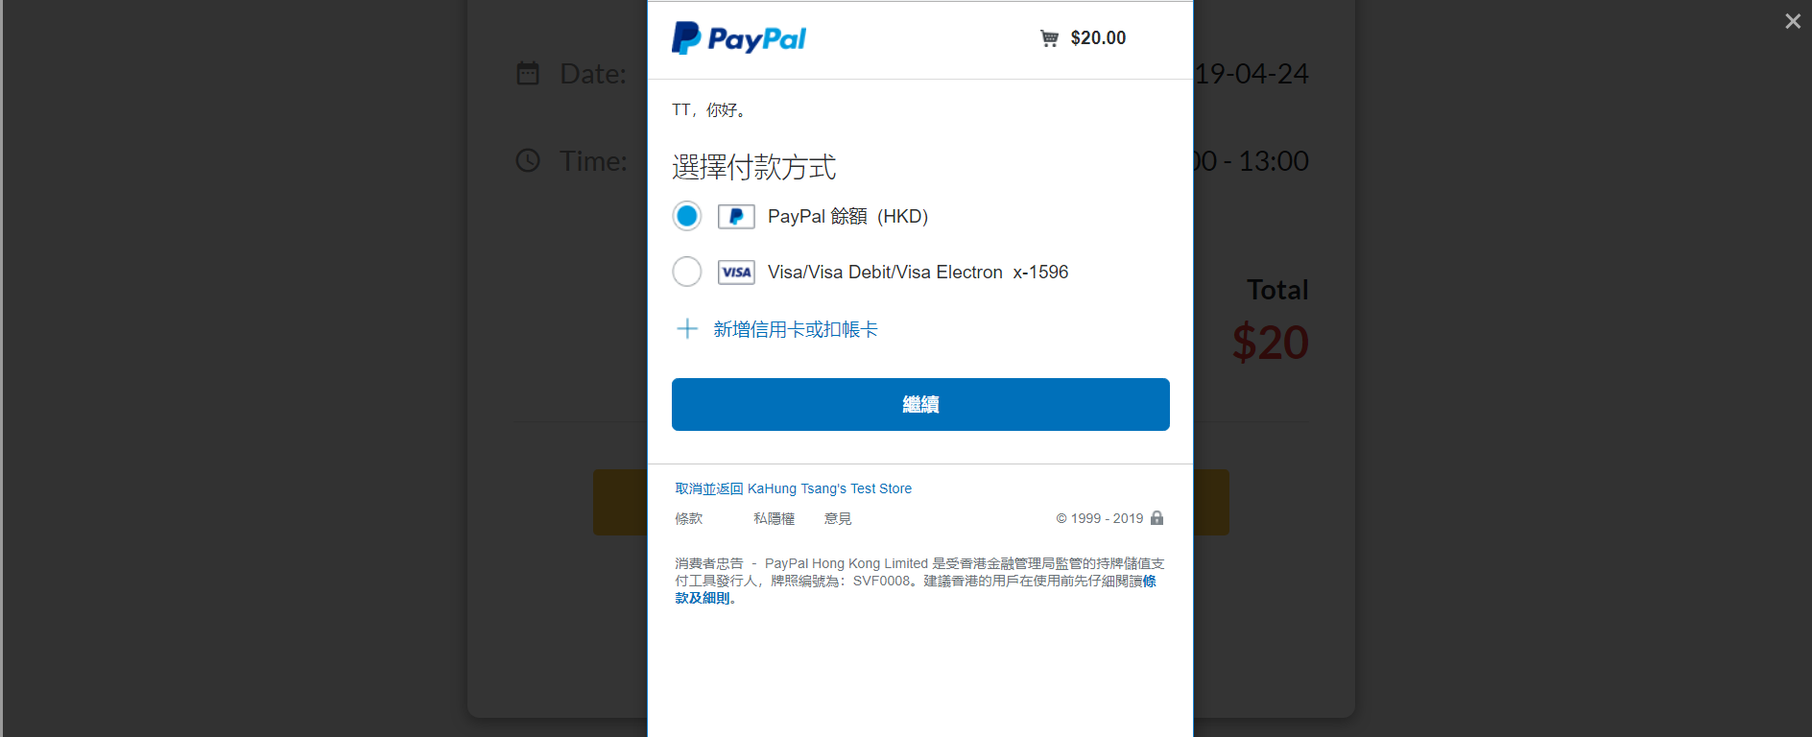

Use Paypal Balance

Use Credit Card

Continue

Add New Credit Card

1. Payment Confirmation

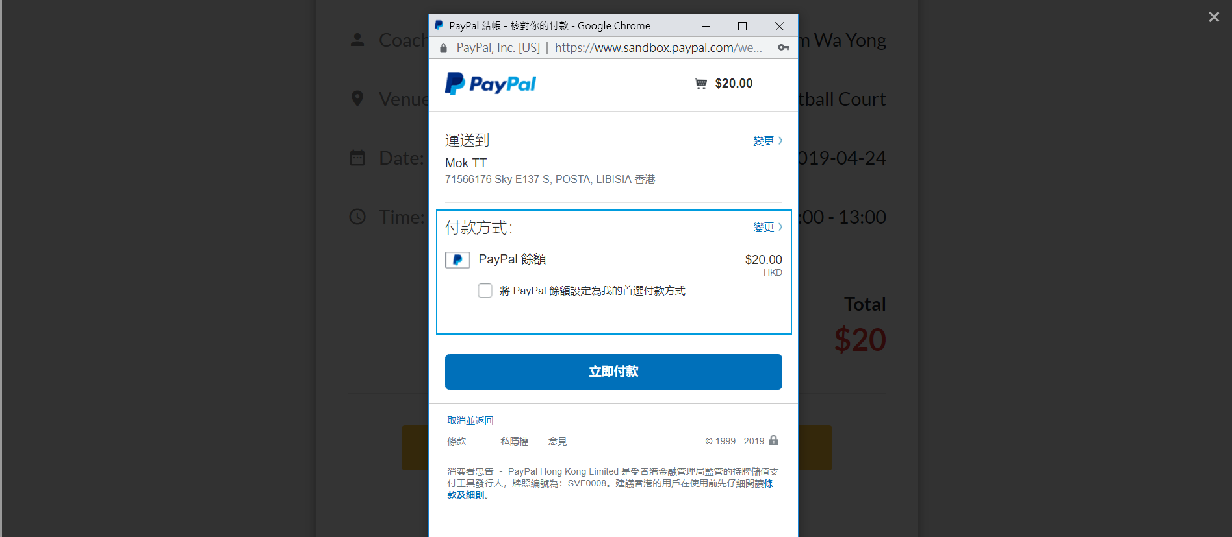

Confirm Payment

Payment Amount and Method

1. Make Payment Without Login

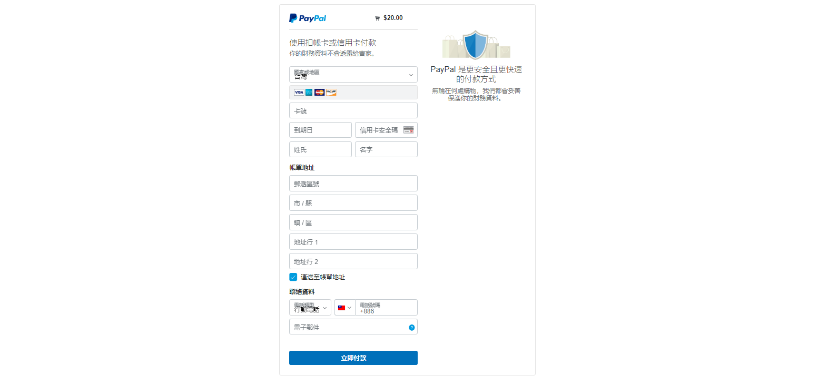

Input Contact Information

Make Payment

Input Billing Address

Input Credit Card Information